|  |  |
| --- | --- |
|  | **<Indian NGO’s Management System>**  **Technical Design Document** |
| |  |  |  |  | | --- | --- | --- | --- | |  | **Prepared By / Last Updated By** | **Reviewed By** | **Approved By** | | **Name** | Movva Hemchand | G S Kannan |  | | **Role** | CSD Intern | Trainer |  | | **Signature** | M Hemchand |  |  | | **Date** | 01/04/2024 |  |  | |
|  |

Table of Contents

1.0 Introduction 3

1.1 Purpose of this document 3

1.2 Project overview 3

2.0 Solution Summary 3

2.1 Scope 3

2.2 Assumptions and Constraints 3

2.3 Dependencies 4

2.4 Risks 4

**3.0 Requirements 4**

**3.1 Functional Requirements 4**

**3.2 Software Requirements 4**

4.0 Schematic Diagram 5

5.0 System Design 6

5.1 Proposed design 6

5.2 Component inventory 7

6.0 Database Design 8

6.1 Data Model 8

6.2 Tables Structure 8

7.0 Appendices 10

7.1 Glossary 10

7.2 Other 10

8.0 Terms & Conditions 10

9.0 Change Log 11

# Introduction

## Purpose of this document

The purpose of this document is to document the technical design, component details and Database design. This will also capture the scope, assumptions, risk, dependencies of this project.

## Project overview

The primary goal of this project is to Manage the all details of transactions towards each Non Governmental Organizations(NGO) presented in India. Not only transactions, it also manages the details of the fund donors from each state, etc. It mainly overcome the difficulty in finding the NGO for donating the fund, based on the state and the sectors that is working on.

# Solution Summary

## Scope

The purpose of Indian NGO’s Management system is to ease NGO management and to create a convenient and easy-to-use application for fund donors, trying to donate the money to NGO’s working on different sectors. The system is based on a relational database with its NGO management, user management, etc. We have a database server supporting thousands of NGO across India. Above all, I ensure that I will provide a comfortable experience to the fund donors in finding the Specific NGO.

## Assumptions and Constraints

**Operational Assumptions:** The application assume that users will have basic computer literacy and familiarity with similar software applications.

**Business Assumptions:** The application assumes that a stable internet connection will be available to users for accessing and performing online transactions.

**External Constraints:** The application must comply with the General Data Protection Regulation(GDPR) and ensures that user data is handled securely and in accordance with data protection laws.

**Operational Constraints:** The application must support multiple user roles with different access level, requiring proper user authentication and authorization mechanisms.

**Performance Constraints:** The application must handle concurrent requests from a minimum of 500 users and maintain a response time of under 2 seconds nder normal operating conditions.

## Dependencies

*<No dependencies found till now>*

## Risks

*<No risks found till now>*

# Requirements

## Functional Requirements

1. Login Management:

* Adding Signup/Login functionality for both User and Administrator.
* Storing the Login details like username and password of the user in database, For authentication check while logging into their account.

1. Administrator Functionalities:

* Performing CRUD operations on database

1. Fund Donar Functionalities:

* Filtering the NGO’s by sectors and state wise.
* Selecting the NGO to donate the money.
* Transfer the fund by choosing different Payment modes.

## Software Requirements

* MySQL Workbench
* MySQL Server
* Eclipse IDE
* Spring Tool Suit(STS)
* Postman
* Node.js

# Schematic Diagram

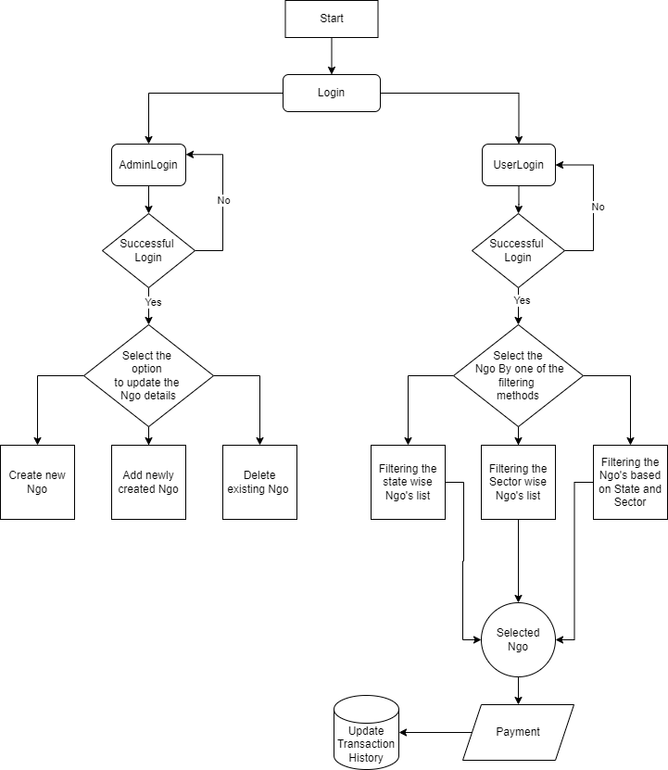

# System Design

## Proposed design

### Admin Use Case diagram

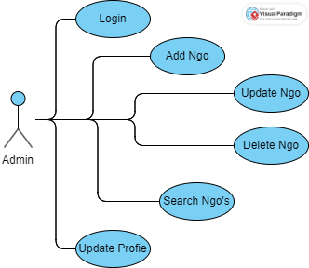

### User Use Case Diagram

### Sequence diagram

## Component inventory

*<Yet to add>*

# Database Design

## Data Model

## Tables Structure

1. **States**

|  |  |  |  |
| --- | --- | --- | --- |
| **Column Name** | **Data Type** | **Length** | **Nulls** |
| state_id | Varchar | 2 | No |
| state_name | Varchar | 255 | No |
| ngo_count | Int | - | - |
| received_fund_in_rupees | double | - | - |

1. **Ngo_Details**

|  |  |  |  |
| --- | --- | --- | --- |
| **Column Name** | **Data Type** | **Length** | **Nulls** |
| ngo_id | Varchar | 12 | No |
| ngo_name | Varchar | 510 | No |
| state_id | Varchar | 2 | No |
| city | Varchar | 255 | Yes |
| address | Varchar | 1020 | Yes |
| received_fund_in_rupees | Double | - | - |

1. **Sectors**

|  |  |  |  |
| --- | --- | --- | --- |
| **Column Name** | **Data Type** | **Length** | **Nulls** |
| s_no | Int | - | No |
| sector_name | Varchar | 255 | No |
| ngo_id | Varchar | 12 | No |

1. **AdminDetails**

|  |  |  |  |
| --- | --- | --- | --- |
| **Column Name** | **Data Type** | **Length** | **Nulls** |
| admin_id | Varchar | 8 | No |
| admin_name | Varchar | 255 | No |
| admin_email | Varchar | 255 | No |
| admin_phone | Varchar | 10 | No |
| State_id | Varchar | 2 | No |
| password | Varchar | 20 | No |

1. **UserDetails**

|  |  |  |  |
| --- | --- | --- | --- |
| **Column Name** | **Data Type** | **Length** | **Nulls** |
| user_id | Varchar | 13 | No |
| user_name | Varchar | 255 | No |
| user_email | Varchar | 255 | No |
| user_phone | Varchar | 10 | No |
| state_id | Varchar | 2 | No |
| passowrd | Varchar | 20 | No |

1. **DonationsHistory**

|  |  |  |  |
| --- | --- | --- | --- |
| **Column Name** | **Data Type** | **Length** | **Nulls** |
| donation_id | Varchcar | 255 | No |
| user_id | Varchar | 13 | No |
| sector | Varchar | 255 | No |
| ngo_id | Varchar | 12 | No |
| donated_fund_in_rupees | Double | - | - |
| date | Varchar | 255 | No |

# Appendices

## Glossary

|  |  |
| --- | --- |
| **Acronyms** | **Definitions** |
| NGO | Non-Governmental Organization |
| GDPR | General Data Protection Regulation |

## Other

# Terms & Conditions

***Disclaimer: Please do not circulate or distribute this document outside of Cognizant Network, We have a Zero Tolerance Policy. Kindly adhere to 100% Compliance at all times.***

# Change Log

*Please note that this table needs to be maintained even if a Configuration Management tool is used.*

|  |  |  |  |  |
| --- | --- | --- | --- | --- |
| Version Number | Changes made | | | |
| V<n.n> | *<If the change details are not explicitly documented in the table below, reference should be provided here>* | | | |
| Page no | Changed by | Effective date | Changes effected |
|  |  | 20-03-2024 | Requirements |
|  |  | 28-03-2024 | Database Design |
|  |  | 01-04-2024 | Use case and sequence diagrams |
|  |  |  |  |